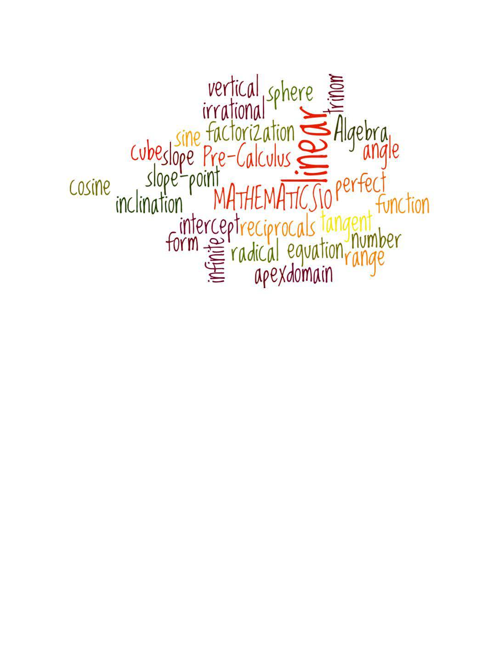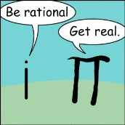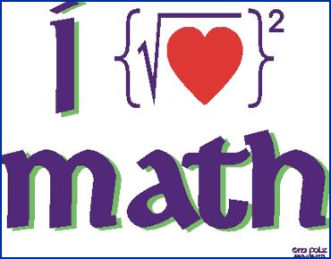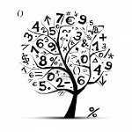C:\STOCKLAYOUTS\CURRENT PROJECTS\FN99803-PL\FN99803-IMG11.emfC:\STOCKLAYOUTS\CURRENT PROJECTS\FN99803-PL\FN99803-IMG10.emf

Geometry

&

Personal Finance

*Foundations and Pre-calculus*

Ms. Johnston Banser

This is a general math course dealing with a number of different mathematical concepts and develops a number of basic math skills.

*Course Evaluation:*

***Your effort will determine your outcome.***

*Term work will count for 80% of your total grade. There will be a Final Exam worth 20% of your total grade.*

Strands:

Algebra and Number Chapter 3: Factors and Products

Chapter 4: Roots and Powers

Cumulative Review: Chapters 3 – 4

Relations and Functions Chapter 5: Relations and Functions

Chapter 6: Linear Functions

Chapter 7: Systems of Linear Functions

Cumulative Review: Chapters 3 -7

Measurements & Finance Chapter 1: Personal Finance

Chapter 2: Trigonometry

Cumulative Review: Chapters 1 - 7

Algebra

&

Number

Relations &

Functions

Math 10

Course

Expectations

**~ Workload:** There is an ENORMOUS amount of material to be covered in this course. This is attainable (and definitely possible) when you follow the following guidelines:

~ **Class Time** – MOST IMPORTANT. Must be used efficiently and properly. When assigned in class work, it must be completed 'in class'. Fooling around and putting work off will be a detriment to your success.

**~ Assignments** – All assignments should be completed immediately. Do not leave them to the last minute!

**~ Homework** – Expect nightly homework **IF** your work is not completed in class!!! Practice work is reflected in your work ethic mark.

**~ Attendance** – With legitimacy (note from home), I will make every effort to help you get caught up on missed classes. It is, however, your responsibility to find out what you missed and get the notes. You will be able to do this through a friend or the **website**. Make sure you check it before you return to class and make every effort to get yourself caught up. If you have missed a test, you will need to provide a note and must write the test within 3 school days.

Do not be late to class!

A NOTE ABOUT STUDYING FOR MATH TESTS…

It is instrumental to success in this course to study for all math tests. Many students, however, have not yet developed effective math study skills. The best way to study is to practice, practice, practice – go over questions from your notes and the textbook, again and again. Drill and practice will make you comfortable with the techniques and theories in the course and give you the confidence to succeed.

To be successful at anything (sports, job, music, driving, etc) you must practice, practice, practice. To only read about something will not give you the skills to succeed. This is very true with math as well!

Remember: This course is heavily weighted on tests!

Textbook:

Foundatoins and Pre-Calculus Mathematics 10

Notebook (lined & graph paper)

Pen

Pencil x2

Eraser

Ruler

Scientific Calculator

**Class**

**Supplies:**

**Bring To every class**

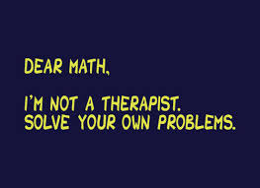

 Ms. Johnston Banser

Contact Information:

michelle.johnstonba.sd23.bc.ca

Room 290

Website: www.johnstonbanser.weebly.com